**TaskPlanner**

**Introduction**

Our project is a Task Planner designed to help students like us stay organized and manage our time better. It lets you list your tasks, set deadlines, and keep track of what needs to be done. The goal is to make planning easier and less stressful, so it’s not overwhelming when you have a lot on your plate. It’s a simple way to stay focused and avoid falling behind.

**Problem Statement**

Many students, including ourself, often feel overwhelmed trying to balance school, homework, personal life, and other responsibilities. It’s easy to lose track of deadlines, forget important tasks, or leave things until the last minute. This creates a lot of unnecessary stress and can hurt our grades and overall well-being. The real issue is that we don’t always have a simple, reliable way to organize everything in one place. Our Task Planner aims to solve this by offering an easy-to-use tool that helps students plan their days, set priorities, and keep track of tasks. By staying organized, we can reduce stress, avoid procrastination, and feel more in control. This kind of tool is especially important for building good habits and managing time better in the long run.

**Objectives**

The goal of our project is to help students stay organized and manage their tasks with less stress. It’s designed to improve time management, encourage better planning habits, and make handling schoolwork feel easier and more manageable.

**Technology Stack**

* - Frontend: React, TailwindCSS
* - Backend: Js
* - Database: Browser Local Storage
* - Tools: Git, GitHub, Visual Studio Code
* **Installation Instructions**
* Step-by-step guide to set up the project locally.
* # 1. Clone the repository
* git clone https://github.com/rozakudabay/DailyTaskPlanner_15P.git
* # 2. Navigate into the project directory
* cd DailyTaskPlanner_15P
* # 3. Install dependencies
* npm install
* # 4. Start the application
* npm start

**Usage Guide**

1. Creating an Account:

* To get started, go to the Sign Up page.
* Enter your details (name, email, and password) and click Create Account.
* You’ll receive a confirmation email to verify your account.

2. Signing In:

* Once your account is verified, go to the Sign In page.
* Enter your email and password to log in.
* After signing in, you’ll be directed to your task dashboard.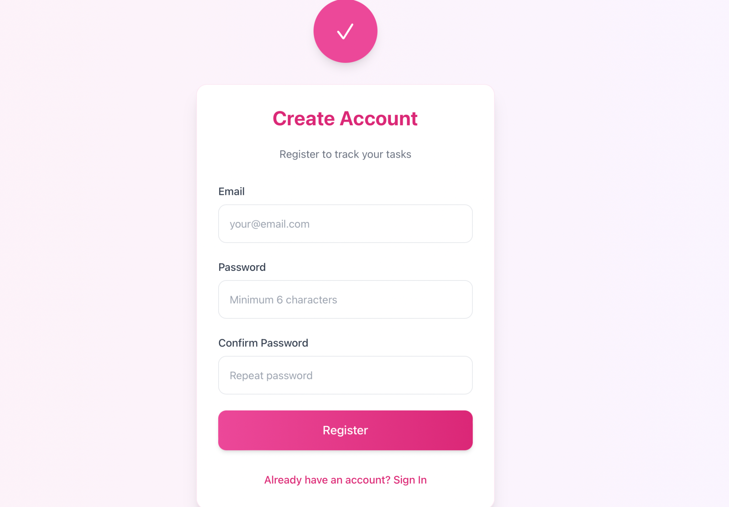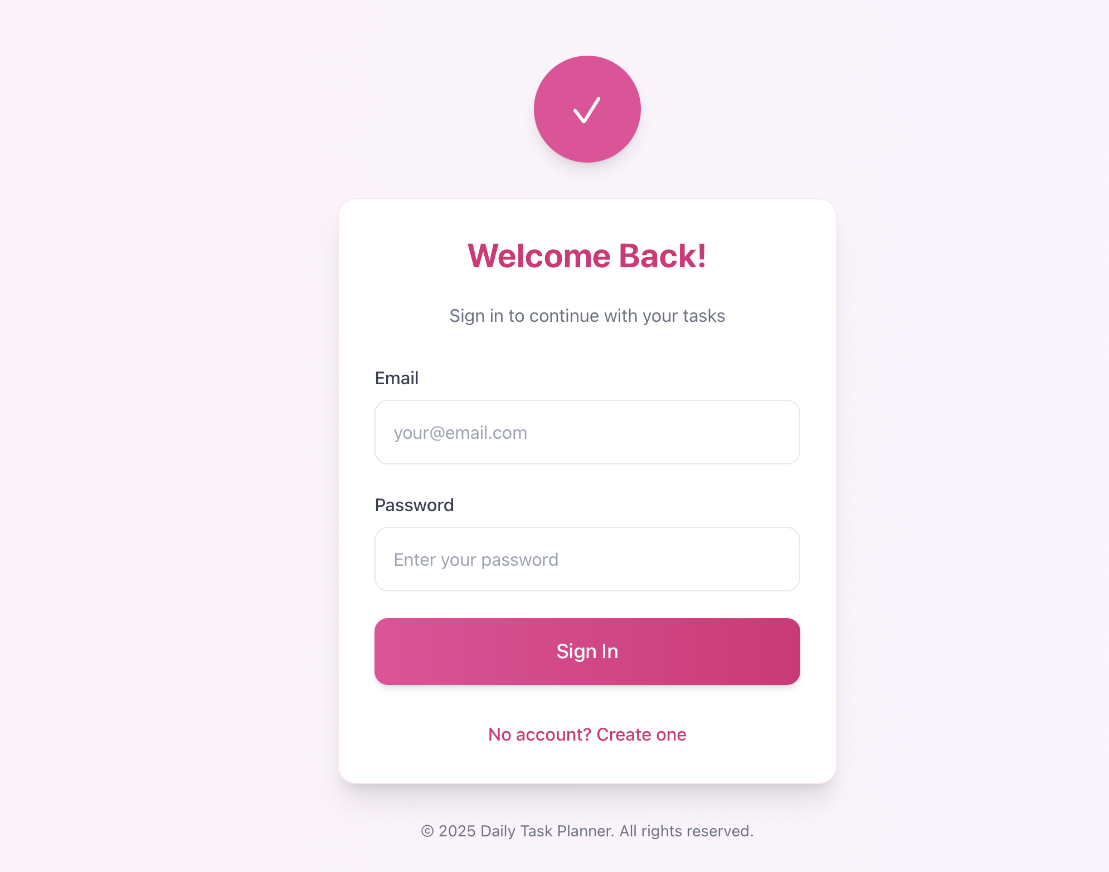

**3. Adding a Task:**

* To add a task, click the **Add Task** button.
* Enter the task name, priority, and due date.
* Click **Save Task** to add it to your list.

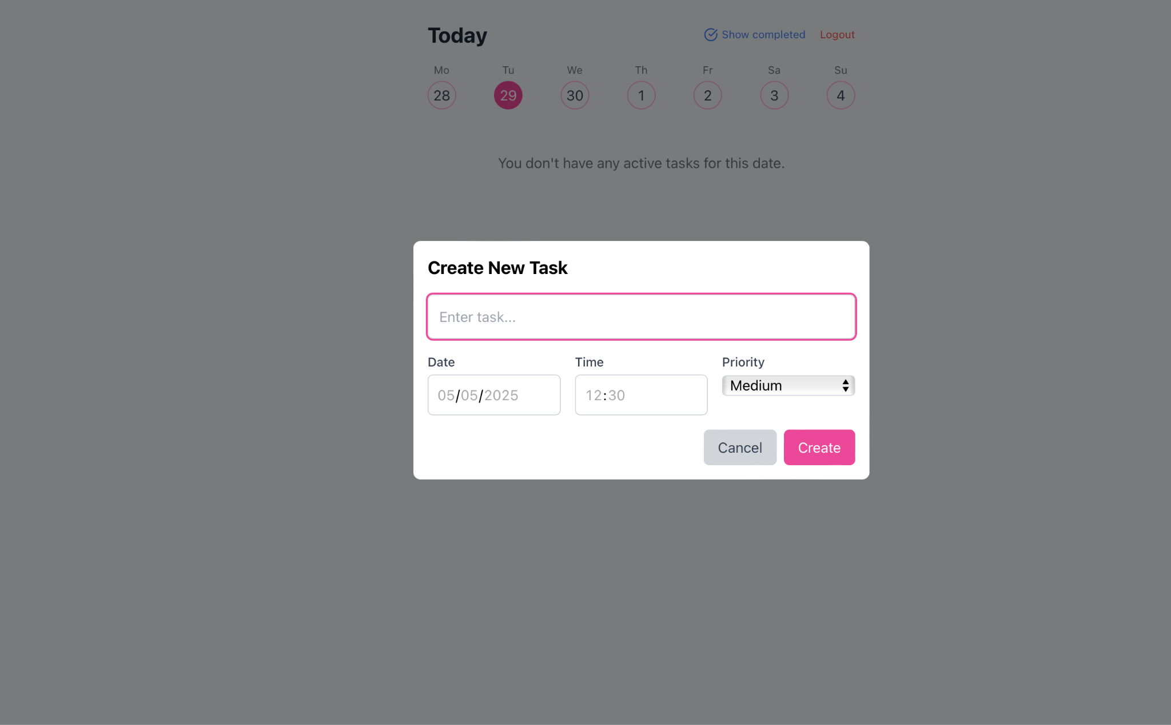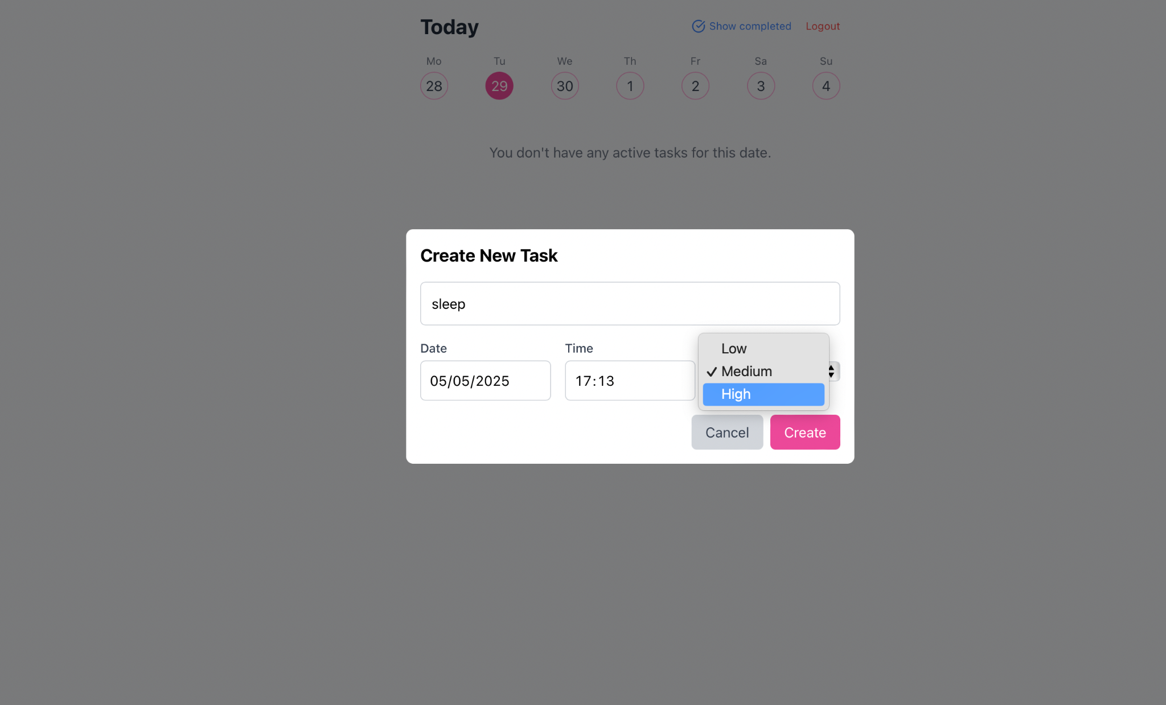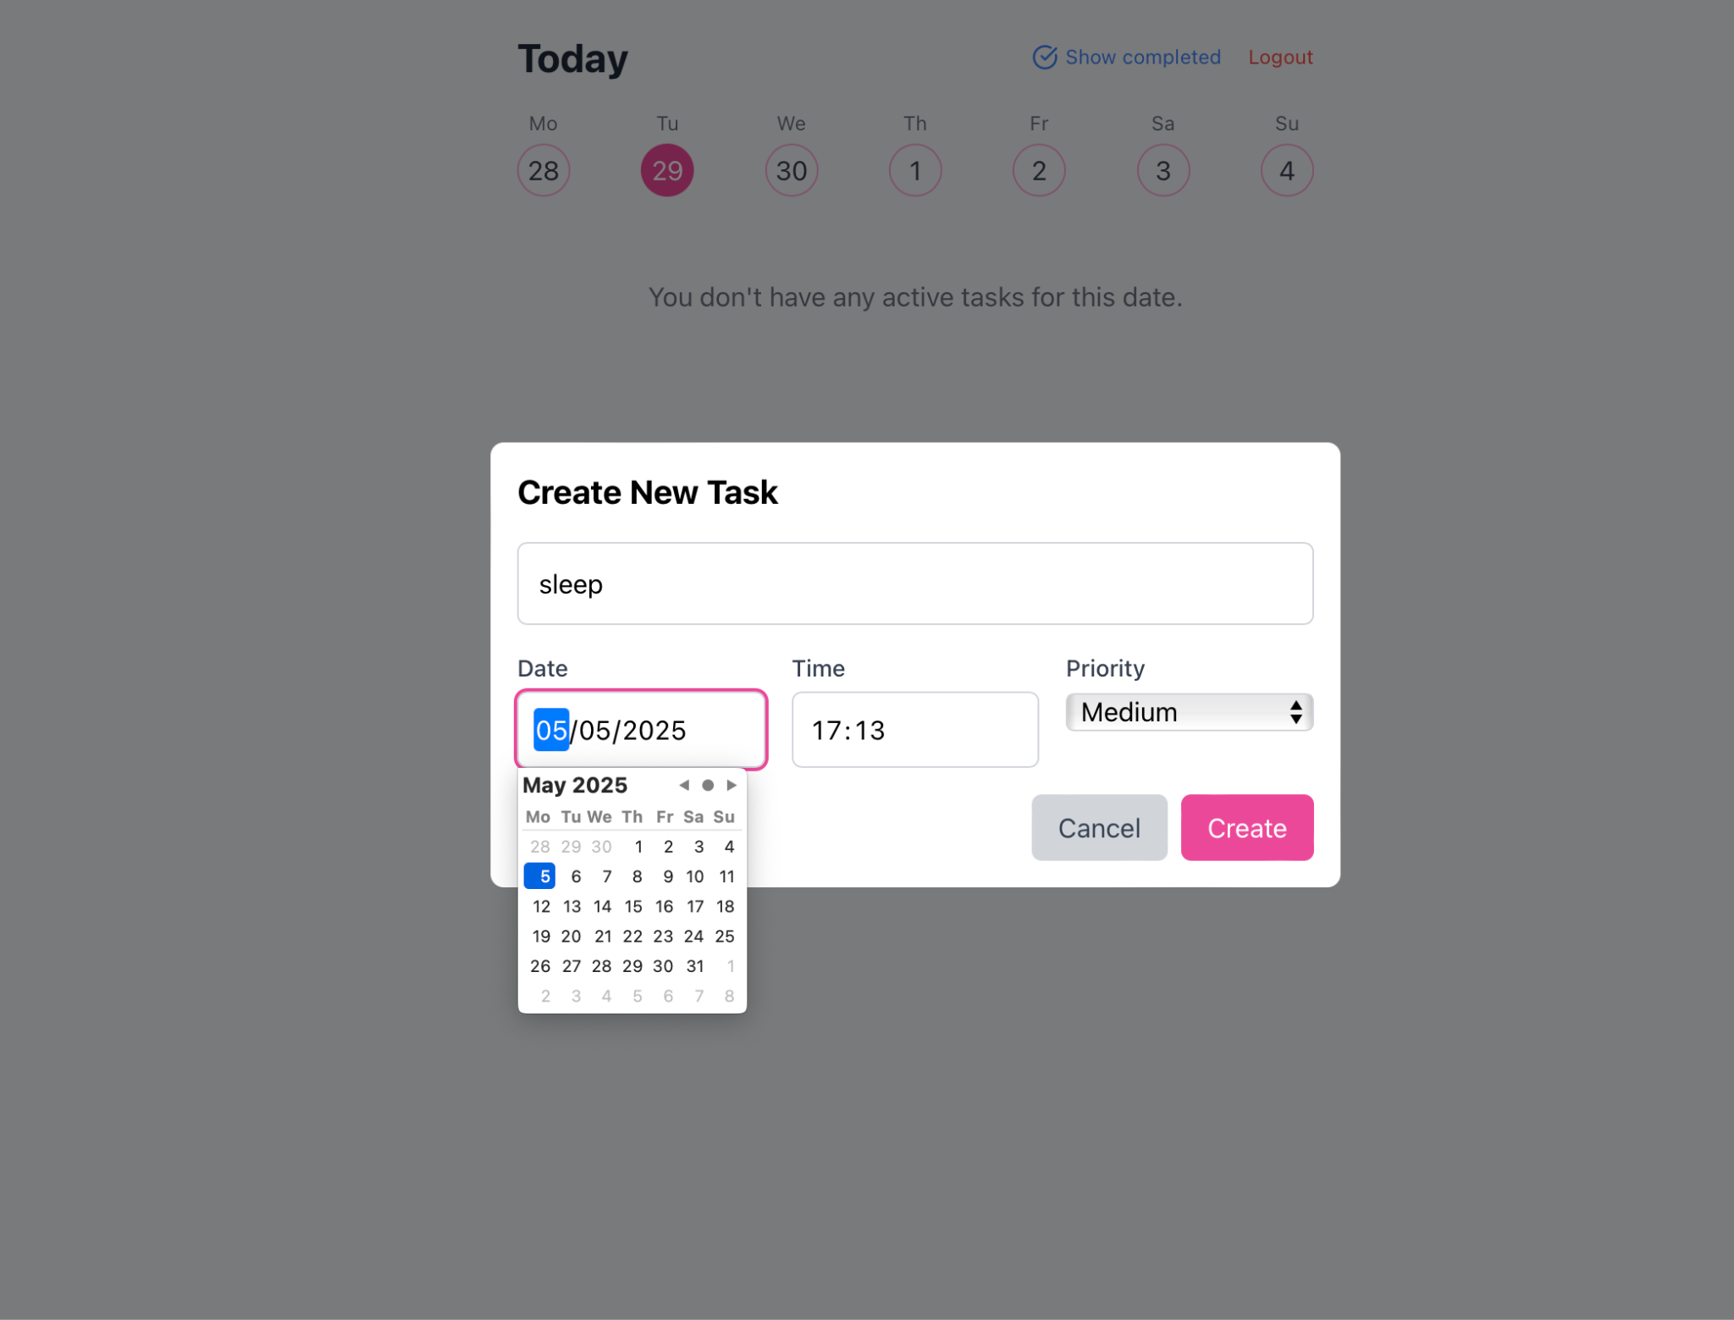

**4. Marking a Task as Complete:**

* When you finish a task, go to your task list.
* Click the checkbox or **Mark as Complete** next to the task.
* The task will move to the **Completed Tasks** section.

**5. Viewing Your Tasks:**

* All your tasks are displayed on the **Task Dashboard**.
* Tasks are sorted into, **In Progress**, and **Completed** sections.
* Use filters to sort by due date or task status.

**References**

[**https://stafiz.com/en/project-monitoring-task-planning-steps/**](https://stafiz.com/en/project-monitoring-task-planning-steps/)

[**https://zapier.com/blog/best-todo-list-apps/**](https://zapier.com/blog/best-todo-list-apps/)

[**Simple Task Management App with HTML CSS and JSYouTube · Learn Web Dev with NorbertJun 19, 2023**](https://www.youtube.com/watch?v=txSwC82v6UM&pp=0gcJCdgAo7VqN5tD)

**Team Members**

* Saparbayeva Aidana 220103143 20-P
* Kudabay Roza 220103280 15-P